Chapter 10, Solution 18.

Consider the circuit shown below.
j6 
2 
4 
8 
445 A
-j2 
2 V_{x}
V₁

V₂

+
V_{o}
−

-j 
+
V_{x}
−

j5 
At node 1,
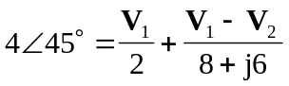
(1)

At node 2,
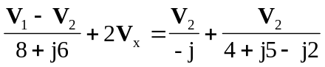, where 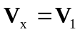
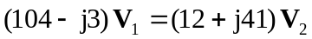
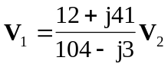 (2)

Substituting (2) into (1),
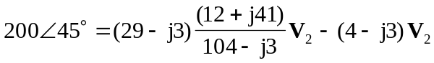
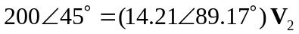
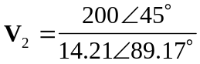

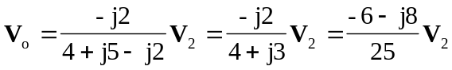
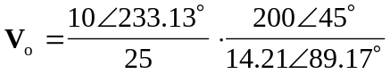

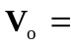 5.63189 V

